**Chapter Preview: Chapter 4 & 5**

Answer the following questions briefly.

1. Explain the concept of time value of money.

* The condition of money having different values depending on the time factor

1. Explain the concepts of compounding and discounting.

* compounding : the act of changing the future value to the present value
* discounting : the act of changing the present value to the future value

1. Explain the NPV (net present value).

* the value at which all the flow of cash is subtracted from the current value

1. What are the annuities? Distinguish a perpetuity from a growing perpetuity.

* Annuities :something that is paid at regular intervals over a fixed period of time
* Perpetuity and growing perpetuity are necessary to provide a fixed amount of money continuously and permanently for each period. But growing perpetuity continues to grow at a fixed rate.

1. What is internal rate of return (IRR)?

* IRR is a Discount rate that equates future revenue generated by the project with the cost of the project, and a value that makes the NPV value "0".

1. What is the difference between nominal and effective interest rate?
2. For a nominal interest rate of 12% per year, determine the nominal and effective rates per year for (a) quarterly, and (b) monthly compounding

* The nominal interest rate does not take into account the specified interest rate, number of benefits, or duration, but the effective interest rate is considered.
* nominal interest : 12%, 12%
* effective interest rate : ${(1+\frac{0.12}{4})}^{4}-1 ≒12. 11\%$, ${(1+\frac{0.12}{12})}^{12}-1 ≒12. 68\%$,

1. Define the continuous compound interest.

* a method of calculating benefits in which the periods of payment of interest generated are continuous

1. Briefly explain following terms:

* Amortizing loans : the remaining amount for the installment loan and principal balance for which monthly payments are applied first to reduce the interest balance. As the loan is redeemed, a substantial portion of the payment is gradually converted into principal, and the portion toward interest is gradually reduced.
* Real interest rate : the rate of interest expressed in units of goods
* Term structure : the interest-rate relationship between other financial instruments that is the same in other characteristics and only in maturity
* Cost of capital : the rate of return required by investors who raise capital

9. Solve the following problems in the textbook;

#4.4, #4.21, #5.12, #5.35

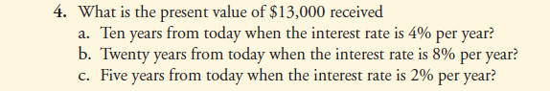

1. $ $\frac{13,000}{{(1+0.04)}^{10}}$ = $8782.33
2. $ $\frac{13,000}{{(1+0.08)}^{20}}$ = $2789.13
3. $ $\frac{13,000}{{(1+0.02)}^{5}}$ = $11774.50

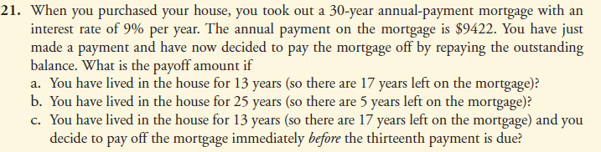

1. $\frac{9422 }{0.09}{(1-\frac{1}{{1.09}^{17}})}^{}$ ≒ $80498.09
2. $\frac{9422 }{0.09}{(1-\frac{1}{{1.09}^{5}})}^{}$ ≒ $36648.29
3. $\frac{9422 }{0.09}{(1-\frac{1}{{1.09}^{17}})}^{}+9422$ ≒ $89,920.09‬



* PMT{6.61(rate)/12 , 60(nper) , 11000(pv) , 0(fv) , 0) = $215.79

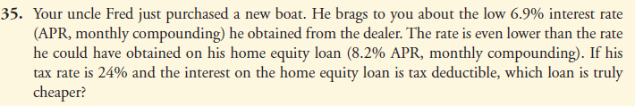

Dealer : 6.9%

home equity loan : {8.2%(APR) * (1-0.24(tax rate))} = 6.232 %

∴ 6.9% > 6.232% => Home equity loan is more cheaper!

*due April 8